**Introduction**

This is not a big project just a small one which is capable of charging 5 Li-ion cells together & the cells are the model of 18650 which is widely used cell in the world even in electric vehicles. It can charge 5 cells using the li ion charging module with a charging current of 1A as the module is capable of this must current only.

**Components Required**

1. 12v/5A SMPS X1
2. Li-ion charging module X5
3. A customized board X1
4. Switch X1
5. 2 pin AC power socket X1
6. 2 pin AC power cable X1
7. Multi-color single strand wire X5 meters
8. Cell holders X5
9. Nuts and bolts X5
10. PVC box X1
11. 7805 Voltage Regulator X 5
12. Capacitor (10uF/16v) X 5

**Components information**

1. 12v/5A SMPS

12v/5A SMPS is used to provide 60Watts of energy but not more than that as it causes an overload in SMPS. Using an SMPS but not a charger as SMPS provides a lot of protection than charger.

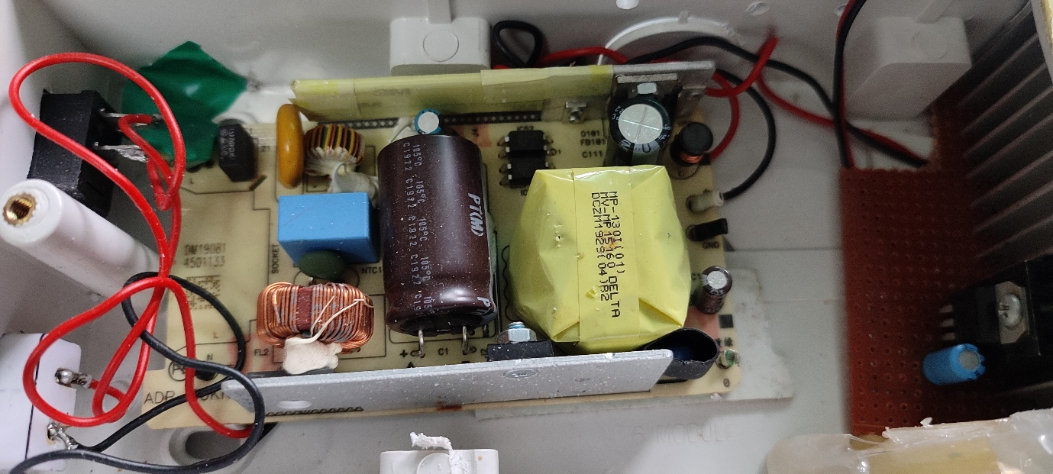

1. Li-ion charging Module.

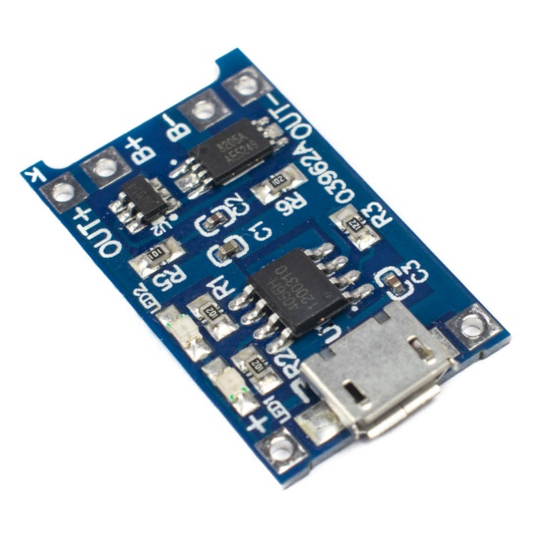

The TP4056 module is a complete constant current-voltage linear charging module for single-cell 3.7 V lithium batteries. During charging and discharging, it will continuously monitor the battery's voltage level and protects against overcharging and undercharging. It features two status outputs, one for charging in progress and the other for charging finished a glowing red LED indicates charging in progress and a glowing blue LED indicates charging complete. It also has a programmable charge current of up to 1A.

Specification: -

1. Input voltage: 4.5 – 5.5v
2. Full charge voltage: 4.25v
3. Full charge indication: Blue LED
4. Charging indication: Red LED
5. Current protection: Yes
6. A Customized Board

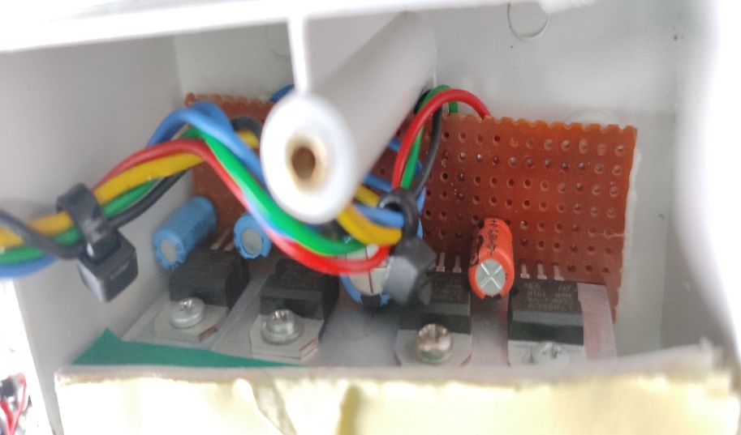 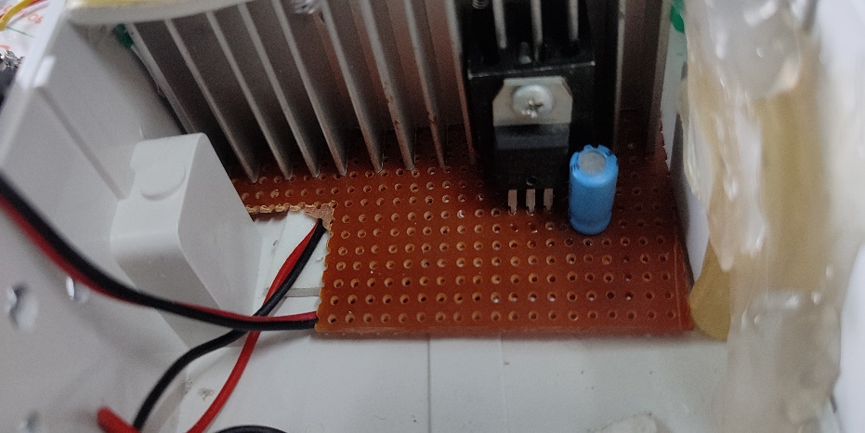

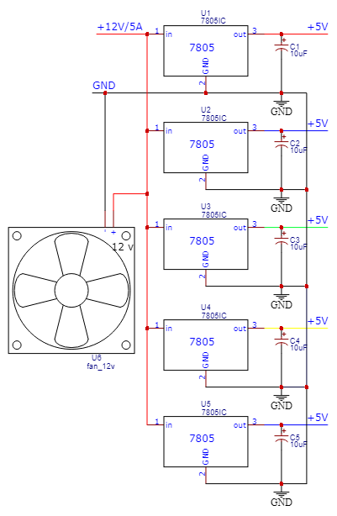

The board is made to convert the voltage from charger i.e., 12v to 5v and 5A of current is distributed into 5 X 7805 voltage IC which will feather provide power to 5 X TP4056 Li-ion charging module. The IC are connected to a large heatsink for power dissipation as these IC’s will produce a very large amount of heat together & to feather cool down the heatsink, we have 12v 0.1A fan connected which will help the heatsink to cooldown.

1. Switch (6A 250V ON/OFF Rocket switch)

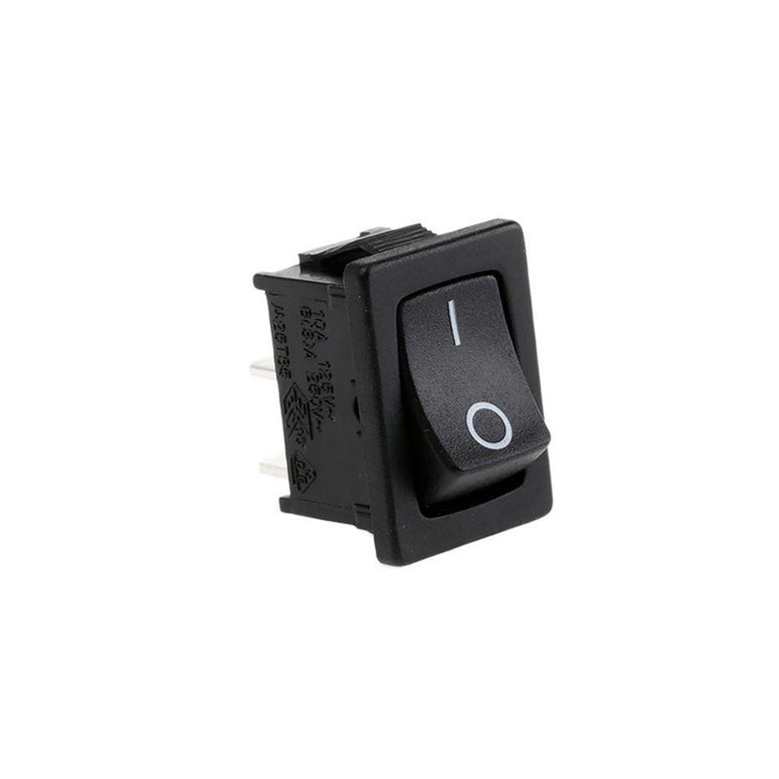

This is used to switch ON/OFF the power supplying to SMPS.

1. 2 pin AC power socket

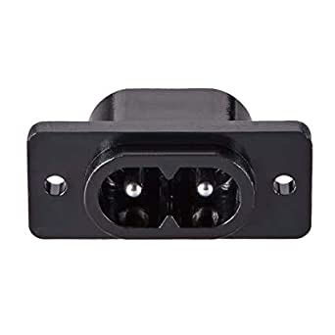

1. 2pin AC power cable

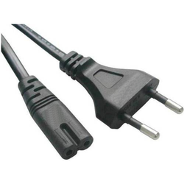

1. Multi-color single strand wire



These wires are used for the connections

1. 18650 Lithium-Ion Cell Holder

The cell holder is used to insert or eject the cell out when in need to replace or use when required. Cell holders are of various types like for AA batteries or AAA batteries or Li-ion battery cell holder.

This cell holder is specifically designed for inserting 18650 Li-ion cell and it can be used for connection rather than using soldering iron on the tip of cell.

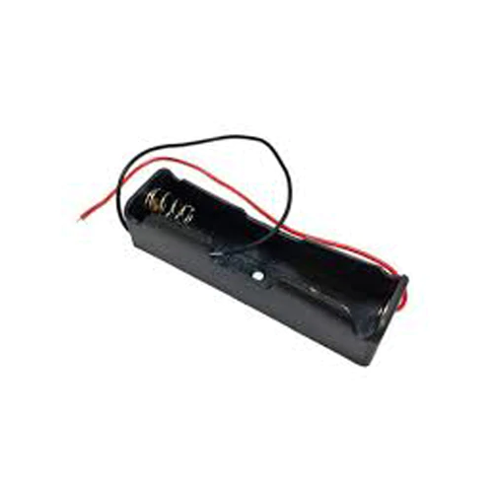

1. PVC Box

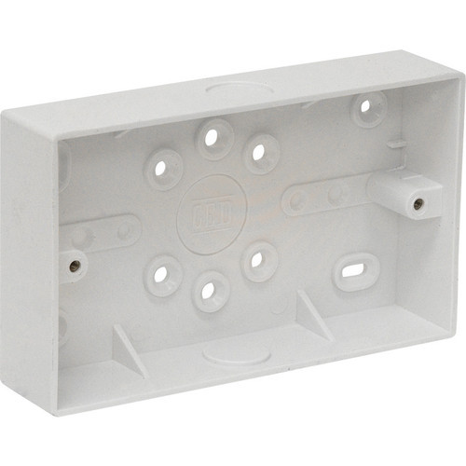

PVC Box should be big enough so that you can accommodate 5 x cell holder and 5 x TP-4056 module together leaving some spaces in between. As well as it depends upon your choice for how many cells you are making it for.

**PROCEDURE**

1. Make two holes one for switch and other for 2 pin AC Power Socket.

1. Now connect two pair of wires on each side of the charger so that from one side we can supply 220v AC and from other end we get 12v/5A DC power.
2. Now connect the charger with switch and 2 pin ac power socket and connect the circuit as shown in the circuit diagram given below.

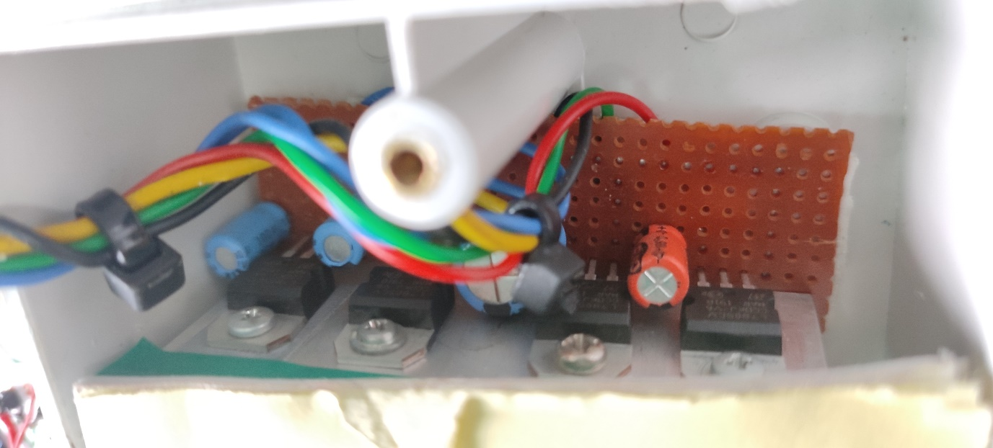

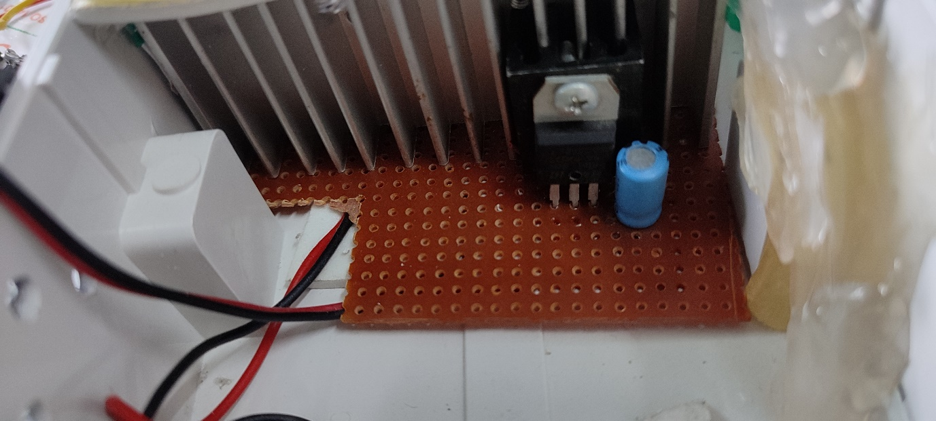

1. Now make some holes so the before installing the circuit in pvc box for heat dissipation

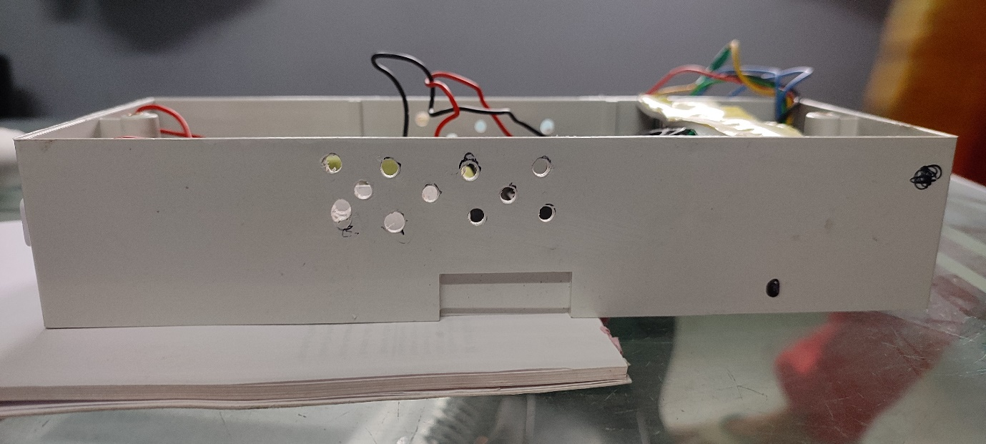

1. Now install the connected circuit in PVC Box

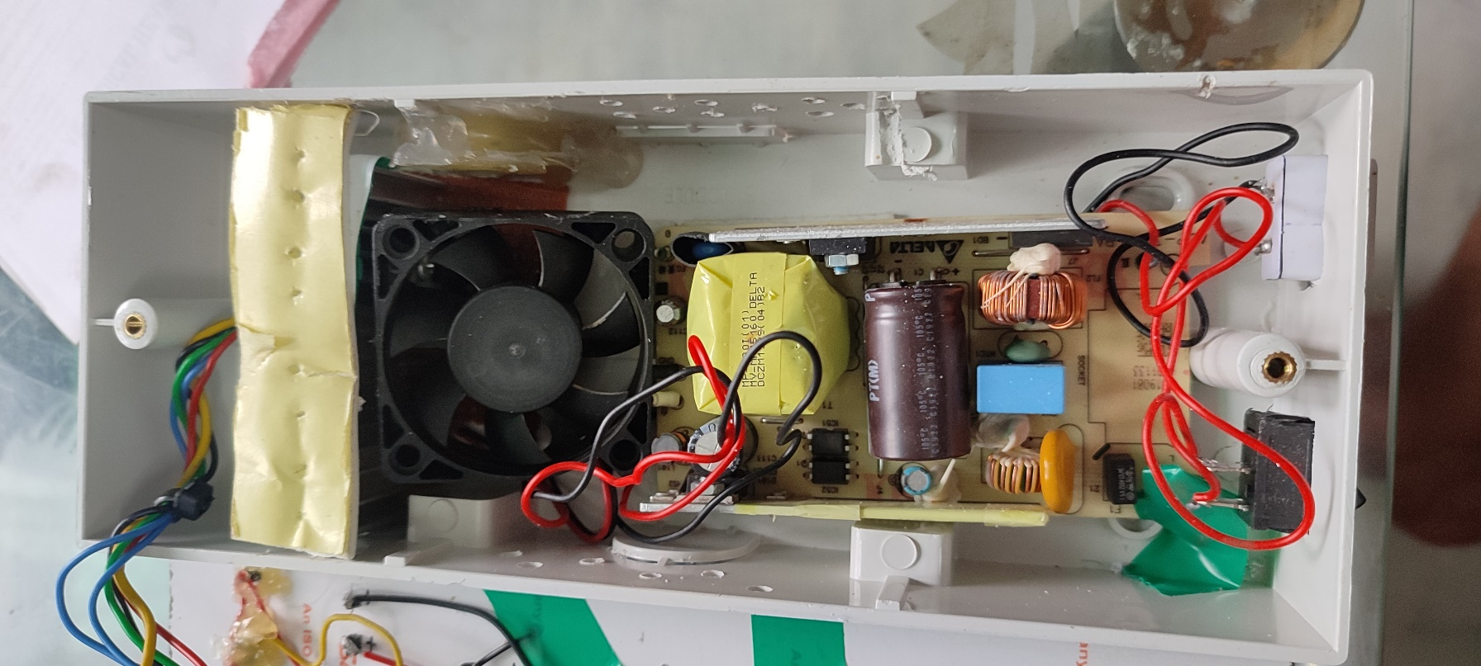

1. Now make the connections for TP4056. I have used cell holders over here.

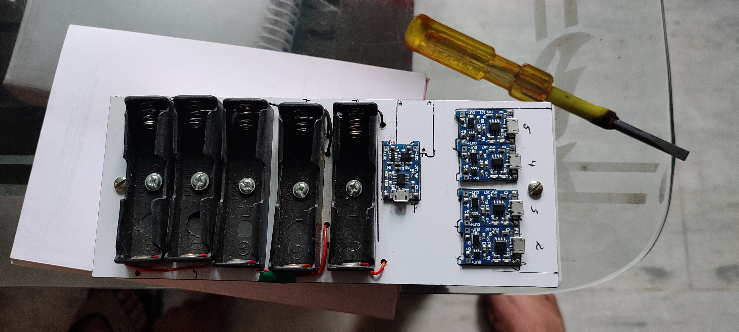

Circuit diagram

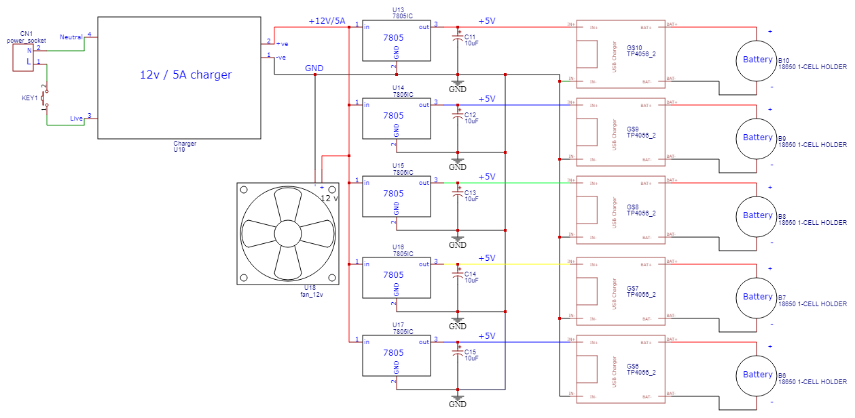

1. After connecting these TP4056 with the customized circuit it should look like this.

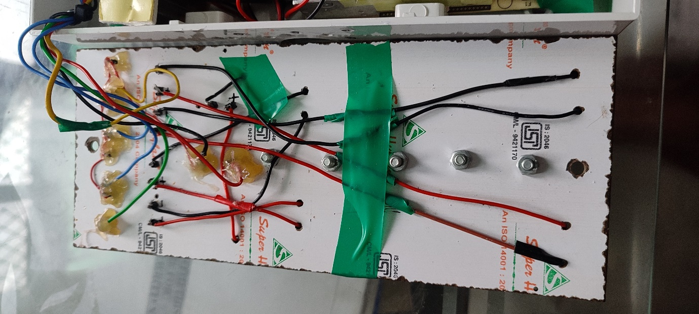

1. After all connection done properly power the circuit with 220v AC and check if TP4056 is working or not and for that if blue light glows in all TP4056 that means it’s working properly & if any module is not working check the connection properly.

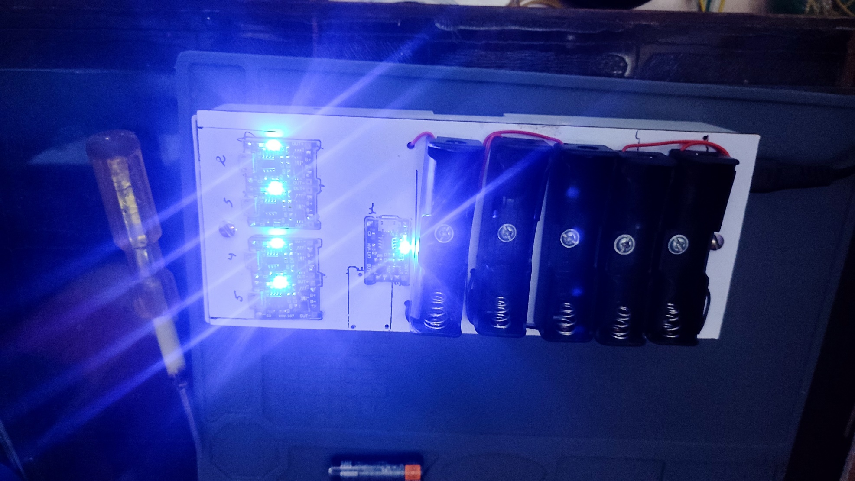

1. Insert 5 X 18650 cells in the sockets and the lights will turn red from blue which indicates that it is charging.

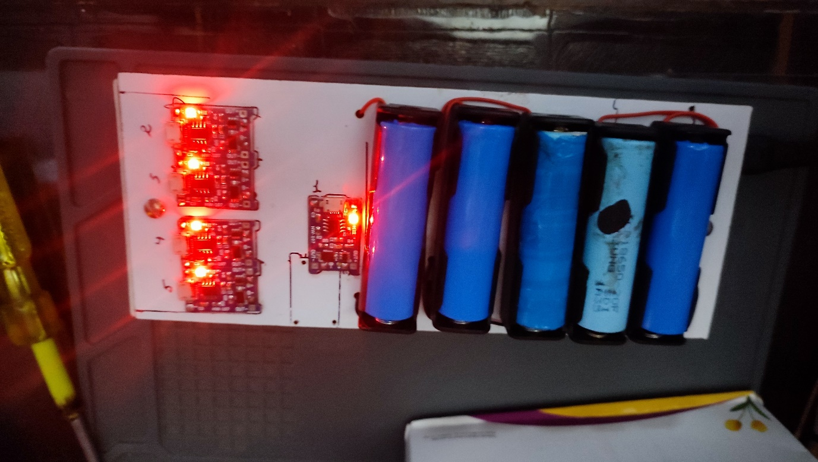

After cells are charged the lights will again turn blue from red.

**RESULTS**

# Test 1

* Max Charging Voltage ( TP-4056) : 4.25±0.05
* Nominal Voltage : 3.7v
* Max Charged Voltage : 4.2v
* Power Input : 220v
* Charging Voltage : 5V
* Input Current : 1A
* Charging Current : 1A
* FAN : ON
* AC : ON
* Test Duration : 2hrs
* Temperature ( HeatSink )

Min : 33.3°

Max : 68°

|  |  |  |
| --- | --- | --- |
|  | Initial Reading | Final Reading |
| CELL 1 ( 18650 ) | 3.61 v | 4.15 v |
| CELL 2 ( 18650 ) | 3.65 v | 4.12 v |
| CELL 3 ( 18650 ) | 3.24 v | 4.14 v |
| CELL 4 ( 18650 ) | 3.36 v | 4.03 v |
| CELL 5 ( 18650 ) | 3.73 v | 4.10 v |

# Test 2 ( Open Box Test )

* Max Charging Voltage ( TP-4056) : 4.25±0.05
* Nominal Voltage : 3.7v
* Max Charged Voltage : 4.2v
* Power Input : 220v
* Charging Voltage : 5V
* Input Current : 1A
* Charging Current : 1A
* FAN : OFF
* AC : OFF
* Test Duration : 2hrs
* Temperature ( HeatSink )

Outside : 43°c

Min : 39° c

Max : 75°c

|  |  |  |
| --- | --- | --- |
|  | Initial Reading | Final Reading |
| CELL 1 ( 18650 ) | 4.07 v | 4.18 v |
| CELL 2 ( 18650 ) | 4.00 v | 4.15 v |
| CELL 3 ( 18650 ) | 3.76 v | 4.17 v |
| CELL 4 ( 18650 ) | 3.78 v | 4.12 v |
| CELL 5 ( 18650 ) | 4.01 v | 4.10 v |

# Test 3 ( Close Box Test )

* Max Charging Voltage ( TP-4056) : 4.25±0.05
* Nominal Voltage : 3.7v
* Max Charged Voltage : 4.2v
* Power Input : 220v
* Charging Voltage : 5V
* Input Current : 1A
* Charging Current : 1A
* FAN : ON
* AC : ON
* Test Duration : 40 min
* Temperature ( HeatSink )

Outside : 40°c

Min : 39° c

Max : 70°c

|  |  |  |
| --- | --- | --- |
|  | Initial Reading | Final Reading |
| CELL 1 ( 18650 ) | 4.01 v | 4.16 v |
| CELL 2 ( 18650 ) | 4.08 v | 4.12 v |
| CELL 3 ( 18650 ) | 4.08 v | 4.16 v |
| CELL 4 ( 18650 ) | 4.03 v | 4.13 v |
| CELL 5 ( 18650 ) | 4.01 v | 4.15 v |